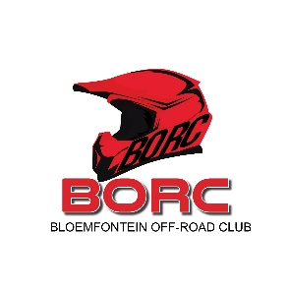**APPLICATION FOR PIT AREA 2025**

NAME:

CURRENT PIT NUMBER:

DO YOU SHARE A PIT: YES NO

MEMBERS OF THE PIT:

CURRENT MEMBER/S: YES NO

MEMBER TYPE: IND FAMILY

BIKE NUMBER/S:

CLASSES COMPETED in 2024:

CLASSES FOR 2025 :

** Note: Please take note that it is the right of the committee to allocate pits according to the successful application.

It is also the duty of the pit owner to comply with the rules of our committee of BORC.

Pit owners hereby agree to keep the pit area neat and tidy.

No pits are allowed to be built unless approved by the committee.

Pits are built at own cost, and may not be removed or demolished, when vacated.

If a pit is not renewed by end of March, it will be available for the next occupant.

No “free” electricity in any pits.

Pre-paid meters need to be installed.

Corrugated iron roofs are only allowed if building plans have been submitted to

Mangaung Metro Municipality at Pit owners own cost.

Only green shade cloth structures to be built in pit area.

When using other types of material, it must be painted dark green. ………….

The pit area is 6 x 9m

Any pit or new pit must have a “pit” number which will be allocated by BORC Club Secretary.

Any pit or new pit must have a “private area” sign. The pit number and Private board is for the pit owner’s expense

**Pit fencing**

Pit fencing is allowed on the front and sides of the pit. Fencing on sides will be on the middle point between two adjacent pits and may extend from front fence to a point level with the back side of the pit and no further. Preferably split pole or similar wood type of fencing or steel poles with chains/cable may be used. No fencing whatsoever is allowed on the back side of pits facing the main Kenilworth Road to preserve space on back side of pits for Visitor’s parking.

Any pit owner must be an active and competing member at BORC.

__________________________ _________________________

Applicant or Pit owner Date